INWOOD BAGELS

BUSINESS REQUIREMENTS

Project: Inwood Bagels

Author: Charles Adams

**Table of Contents**

**1. Project Overview** **3**

**2. Document Information** **3**

2.1 Audience 3

**3. Business Opportunity** **4**

3.1 Project Overview and Background 4

3.2 Current State Analysis 4

3.3 Future State 4

3.4 Business Domain Model and Stakeholders 4

**4. Business Requirements** **5**

4.1 Business Scope 5

4.2 Details of Business Requirements 5

**5. Non-Functional Requirements** **7**

**6. External Data Feeds** **7**

**7. Business Risks** **8**

# 

# 1. Project Overview

This document describes the business/user requirements for the Inwood Bagels Web Application that will provide the basis for the following project activities.

* Introducing business and user requirement
* Identifying stakeholders
* Describe an e-commerce application
* Determine when the project is complete
* Identify guidelines that will signify completion of project

# 2. Document Information

## 2.1 Audience

|  |  |  |
| --- | --- | --- |
| Name | Business Group | Role |
| Customers | Customer Service | Website Users |
| Delivery Services | Daily Needs | Partner/Supplier |
| Payment Merchants | Payment Services | Partner/Supplier |
| Grocery Stores | Day Manager | Supplier |

# 3. **Business Opportunity**

## 3.1 **Project Overview and Background**

A web application for Inwood Bagels that allows users to order food from their computers or mobile devices. The web application will allow customers to order as either a guest or a verified user for pick up or delivery services. Verified, or recurring users, can create an account to access more features that the app offers. Users can redeem and accumulate rewards based on recurring orders. Users can order recurring meals. The app can offer random rewards.

## 3.2 **Current State Analysis**

Inwood bagels has the Point of Sales system Clover to help with credit card payments. The web application has a home page that can navigate to the other sections: Menu, Order Online, Directions, Contact Us, Sign In and Sign Up.

## 3.3 **Future State**

The website will allow the business owner to manage the website through an admin page. Through the admin will lists the items and their quantity, which will allow business owner to see if an item is low on stock. On the customer side of the website, customers will have a perk membership that will allow customers to receive a reward after the nth purchase. The customer section will also have a favorites section where meals they have selected to be favorites, as well as favorites chosen by the web application for them will appear. The customers home page will show suggestions for meals. Allow meals to be ordered at certain times of the day, on days that are open. Eventually, the customer section should store credit card information.

3.4 **Business Domain Model and Stakeholders**

|  |
| --- |
| Food Vendors |
| Credit Card Vendors |
| Delivery Services |
| Future/Current Customers |
| Business Owners |

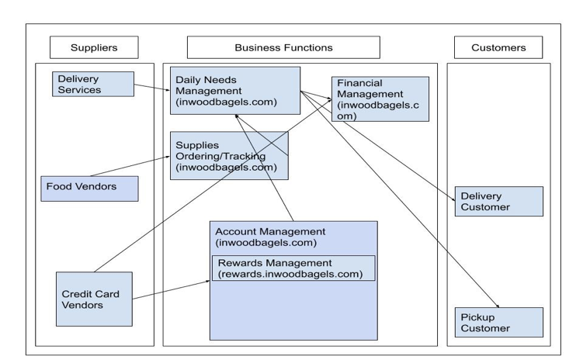

# 4. **Business Requirements**

## 4.1 Business Scope

Inwood Bagels needs a web application to help increase revenue. The site should allow users to have accounts, see the menu and order food, get directions to store and contact the store. Orders need to be tracked so the application can provide a better customer experience. Through a favorites section and suggestions. Orders need to be brokered by a delivery service (Gruhub, UberEATS or Seamless).

Inwood Bagels website needs to include a way for the business owner to manage and control inventory records by having an admin account. The admin account will include sales reports (daily, weekly, monthly, and yearly). This will include orders that are placed for pickup and delivery.

## 4.2 Details of Business Requirements

4.2.1 Account Management

4.2.1.1 Sign Up

4.2.1.2 Sign In

4.2.1.3 See Order History

4.2.1.4 Add Order to list of favorite orders

4.2.1.5 Redeem Rewards

4.2.1.6 View Rewards

4.2.1.7 Sign Out

4.2.1.8 Reorder a previously ordered meal

4.2.2 Daily Needs Management

4.2.2.1 Finalize Order

4.2.2.2 Track items sold daily

4.2.2.3 Create Order

4.2.2.4 Update Item Status

4.2.2.5 Add Item to Order

4.2.2.6 Get Directions To

4.2.2.7 Show a list of all for sale items in a hierarchical manner

4.2.2.8 Send order to Delivery Service

4.2.2.9 Check if delivery services are available

4.2.2.10 Calculate order total

4.2.2.11 Admin account support

4.2.3 Finance Management

4.2.3.1 Make a payment online with credit card

4.2.3.2 Make a payment in cash at time of arrival

4.2.3.3 Calculate Order Tax

4.2.4 Supplies Ordering/Tracking

4.2.4.1 Create Shopping List

4.2.4.2 Set Order Limit for each item

4.2.4.3 Update meal item status

4.2.4.4 Add Item to supply

4.2.4.5 Update Item in supply

4.2.4.5 Connect to Clover POS System

4.2.4.6 Show a list of current inventory

4.2.4.7 Order food needed

4.2.5 Customer Requirements

4.2.5.1 Create an account

4.2.5.2 Add payment method

4.2.5.3 Modify account information

4.2.5.4 Delete Account

4.2.5.5 Ability to purchase food items

4.2.5.6 View order history

4.2.5.7 Contact customer support

4.2.5.8 Ability to redeem perk membership points

4.2.5.9 Earn points for perk membership

4.2.5.10 Ability to checkout as a guest

# 

# 5. **Non-Functional Requirements**

|  |  |
| --- | --- |
| Category | Requirement |
| Usability | The application will be clear in its navigation. The features will be as easy as possible to use. |
| Security | The application needs to be secure from web attacks. |
| Database | Interface with Firebase |
| External Data Feeds | Interface with credit card vendors. Interface with delivery services. |

# 6. **External Data Feeds**

6.1 Process Payment

6.1.1 Customers can purchase an item or more from the menu

6.2 Retrieve Necessary Grocery Items

6.2.1 Bagels are delivered to store, or retrieved from a grocery store

6.3 Online Sharing

6.3.1 Customers can share the experience they had at Inwood bagels on social media, an indirect promotion of Inwood Bagels.

6.4 Informs order status / delivers order

6.4.1 Delivery service notifies user of order status and delivers food to the customers

# 7. **Business Risks**

Risks to Inwood Bagels start with competition from other breakfast/bagel shops in the area. Competition from new shops opening up and others paralleling Inwood Bagels technologically. The cost of delivery services are susceptible to change, as well as, the costs of the web application. Vulnerabilities in the web application and service providers providing the web application’s services. Meeting demand given a new web presence. Loss of sales due to outage.